

# Task 5 – Pass Submission

Student Number: 103542974

Student Name: Hai Hoang Le

### Pass 5a

Paste your screen capture(s) for this task here.

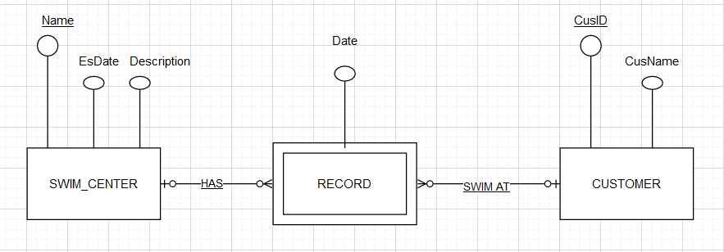

### Pass 5b

Paste your screen capture(s) for this task here.

SWIM_CENTER(Name, EsDate, Description)

PRIMARY KEY (NAME)

CUSTOMER(CusID,CusName)

PRIMARY KEY(CusID)

RECORD(Name, CusID, Date)

FOREIGN KEY(Name) references SWIM_CENTER

FOREIGN KEY(CusID) references CUSTOMER

### Pass 5c

Paste your screen capture(s) for this task here.

CREATE TABLE SWIM_CENTER (

Name VARCHAR(50) PRIMARY KEY,

EsDate DATE,

Description TEXT

);

CREATE TABLE CUSTOMER (

CusID INT PRIMARY KEY,

CusName VARCHAR(50)

);

CREATE TABLE RECORD (

Name VARCHAR(50),

CusID INT,

Date DATE,

PRIMARY KEY (Name, CusID, Date),

FOREIGN KEY (Name) REFERENCES SWIM_CENTER(Name),

FOREIGN KEY (CusID) REFERENCES CUSTOMER(CusID)

);

### Pass 5d

Paste your screen capture(s) for this task here.

Normalization is a process of organizing data in a database so that it is structured in a way that reduces redundancy and improves data integrity. The goal of normalization is to minimize data duplication by breaking down large tables into smaller, more manageable tables that are interconnected through relationships.

### Pass 5e

Paste your screen capture(s) for this task here.

|  |  |  |  |  |  |  |
| --- | --- | --- | --- | --- | --- | --- |
| **CustId** | **Name** | **Phone** | **CarRego** | **MakeModel** | **StartDate** | **ReturnDate** |
| 125 | John | 401112233 | 1AU8HK | Mazda 3 | 31/08/2020 | 7/9/2020 |
| 125 | John | 401112233 | 1LM3AB | Hyundai i30 | 14/11/2020 | 21/11/2020 |
| 278 | Erin | 466121455 | 1AU8HK | Mazda 3 | 19/09/2020 | 12/11/2020 |
| 278 | Erin | 466121455 | 1KA2CA | Toyota Camry | 1/10/2020 | 8/10/2020 |
| 278 | Erin | 466121455 | 1CZ8JK | Mazda 3 | 10/11/2020 | 12/11/2020 |
| 278 | Erin | 466121455 | 1AU8HK | Mazda 3 | 26/11/2020 | 1/12/2020 |
| 721 | Emma | 423544117 | 1LM3AB | Hyundai i30 | 10/9/2020 | 13/09/2020 |